
2026 CALENDAR WWW.AHFNY.ORG 5/11/2026 revised
February 28th  10:00-2:00 PM | Harlem Health Walk (Harry Belafonte Library, Apollo Theater, National Urban League, Sylvia’s, Red Rooster, Renaissance Harlem Hotel) then Lunch  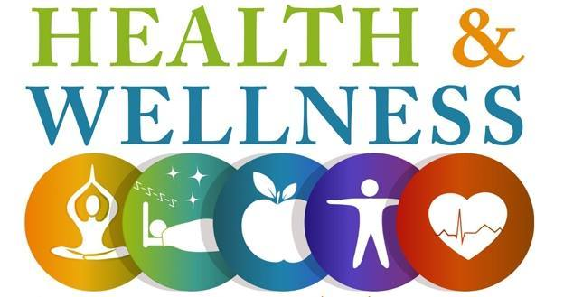 | Meeting Place:  110th Street Malcom X Blvd/Lenox Ave  Leader: VA Executive Chef Chip  Cancelled
March 8-10 | International Food and Restaurant Show!  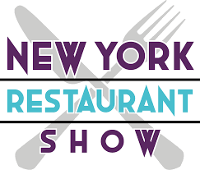  Free to Operator Members with Code | Javits Center  429 11th Ave  New York, NY 10001
April 23rd  10:00-3:00 PM | US Foods Warehouse Tour &  General Mills Culinary Demo & Lunch  Free to Operator Members | Bus will be provided  Leaving 423rd 23 St VA 8AM  To 1051 Amboy Ave  Perth Amboy, NJ 08861  Registration will follow
June 12th  8:00 AM-4:00 PM |   Annual Educational Symposium & Vendor Exhibition  Thrive: The Modern Evolution of Nutrition and Food Service  Sponsored by: AHFNY  4.25 CEU for RD & CDM | Institute of Culinary Education  225 Liberty Street Floor 3  NY, NY 10281  888-929-2433  Registration will follow
August 20-22, 2026 | AHF Annual National Conference   | Hyatt Regency Atlanta  Atlanta, GA
September 24th  9:30 AM-3:00 PM | Curate Long Island BBQ, Wine Tour  & Equipment Exhibition  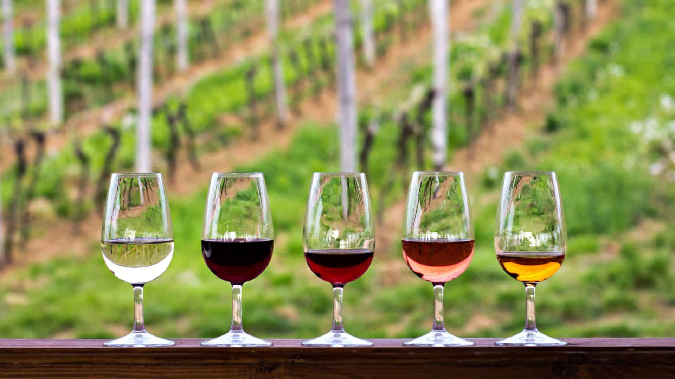  Co-sponsored by: AHFNY and Curate Metro NY  Equipment  Free to Operator Members | Bus will be provided  Leaving 423rd 23st VA Hospital  8AM  Roanoke Vineyards  3543 Sound Ave Riverhead  Registration will follow
October 23rd | Fall Foliage Hudson River Cruise  Stop over Cold Spring Harbor    Co-Sponsored by: AHFNY & PBAC | Meet: Battery Maritime  Building Slip 5, 10 South St. NYC 10005  Registration will follow
November 17th  10-11 AM | Decoding the New Dietary Guidelines for Americans  CEU- TBD | Virtual Panel Discussion  MSK- VA- NYP- JASA
December 8th  6:30-10:30 PM | Holiday Party - Employee Recognition &  Officer Installation    Sponsored by: AHFNY | Vetro  164-49 Cross Bay Blvd. Howard Beach, NY 11414  Registration will follow

